# Appendix

## Hierarchal Blocks

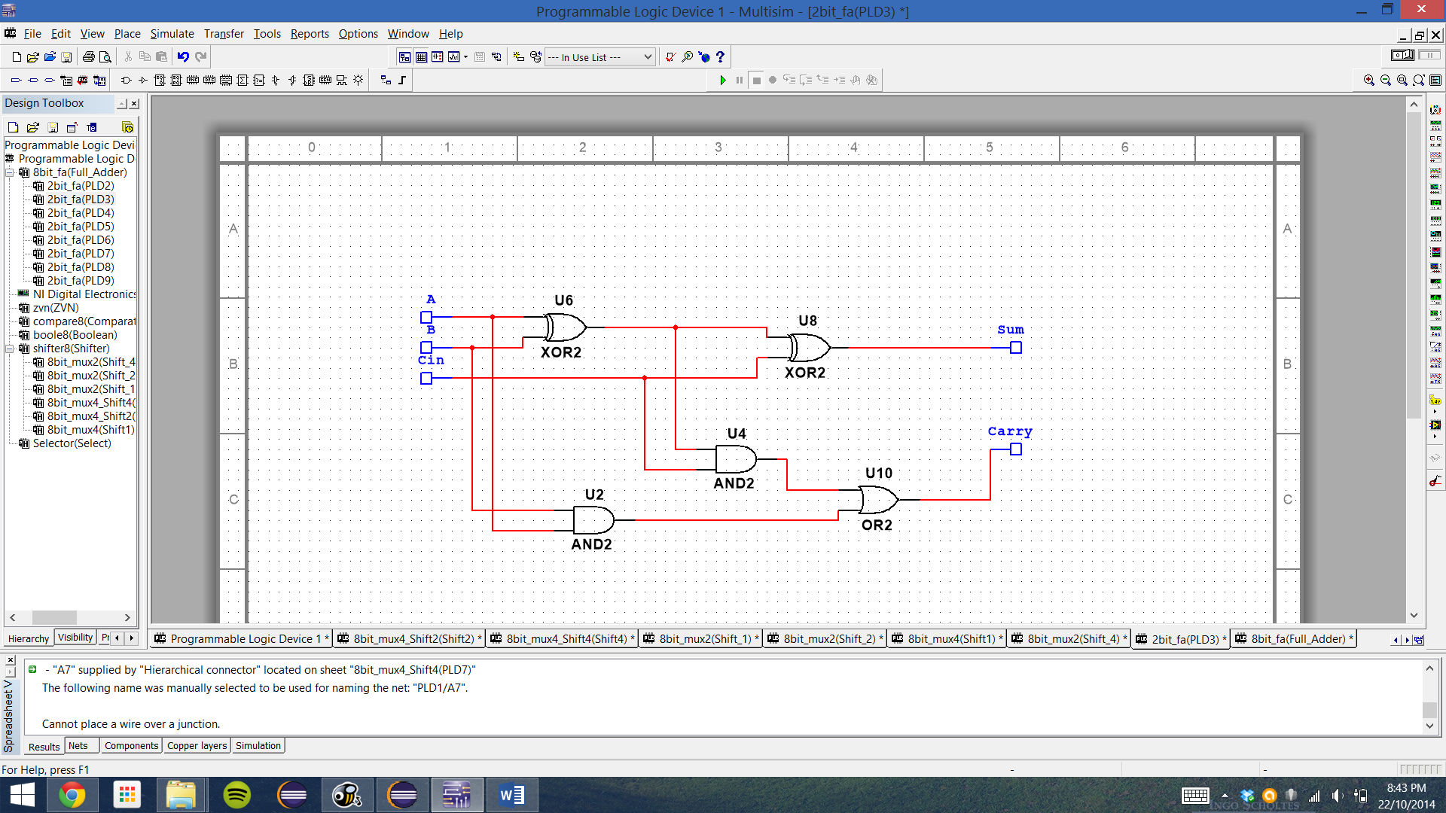

Block 1: Full Adder Block (2bit_fa

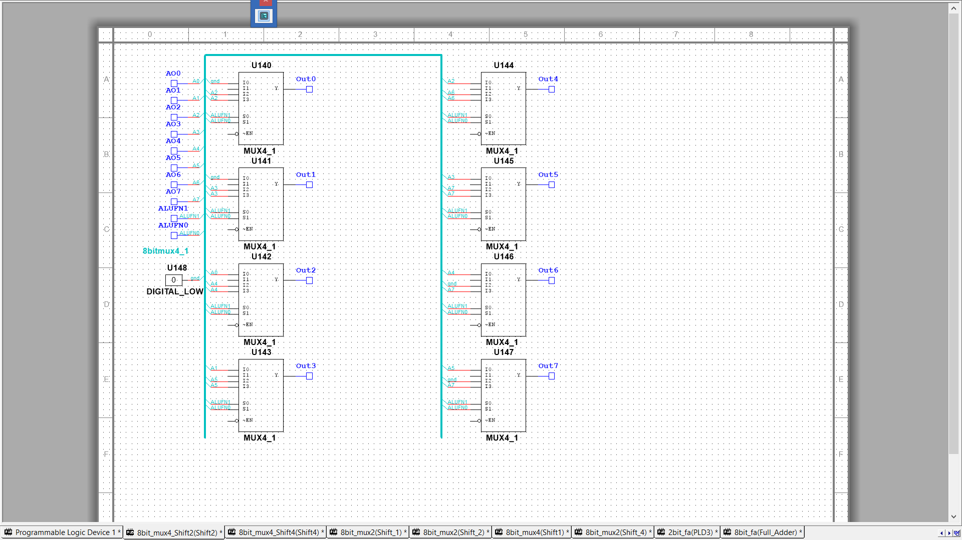

Block 2: 4 Mux 2 bit Shifter (8bit_mux4_Shift4)

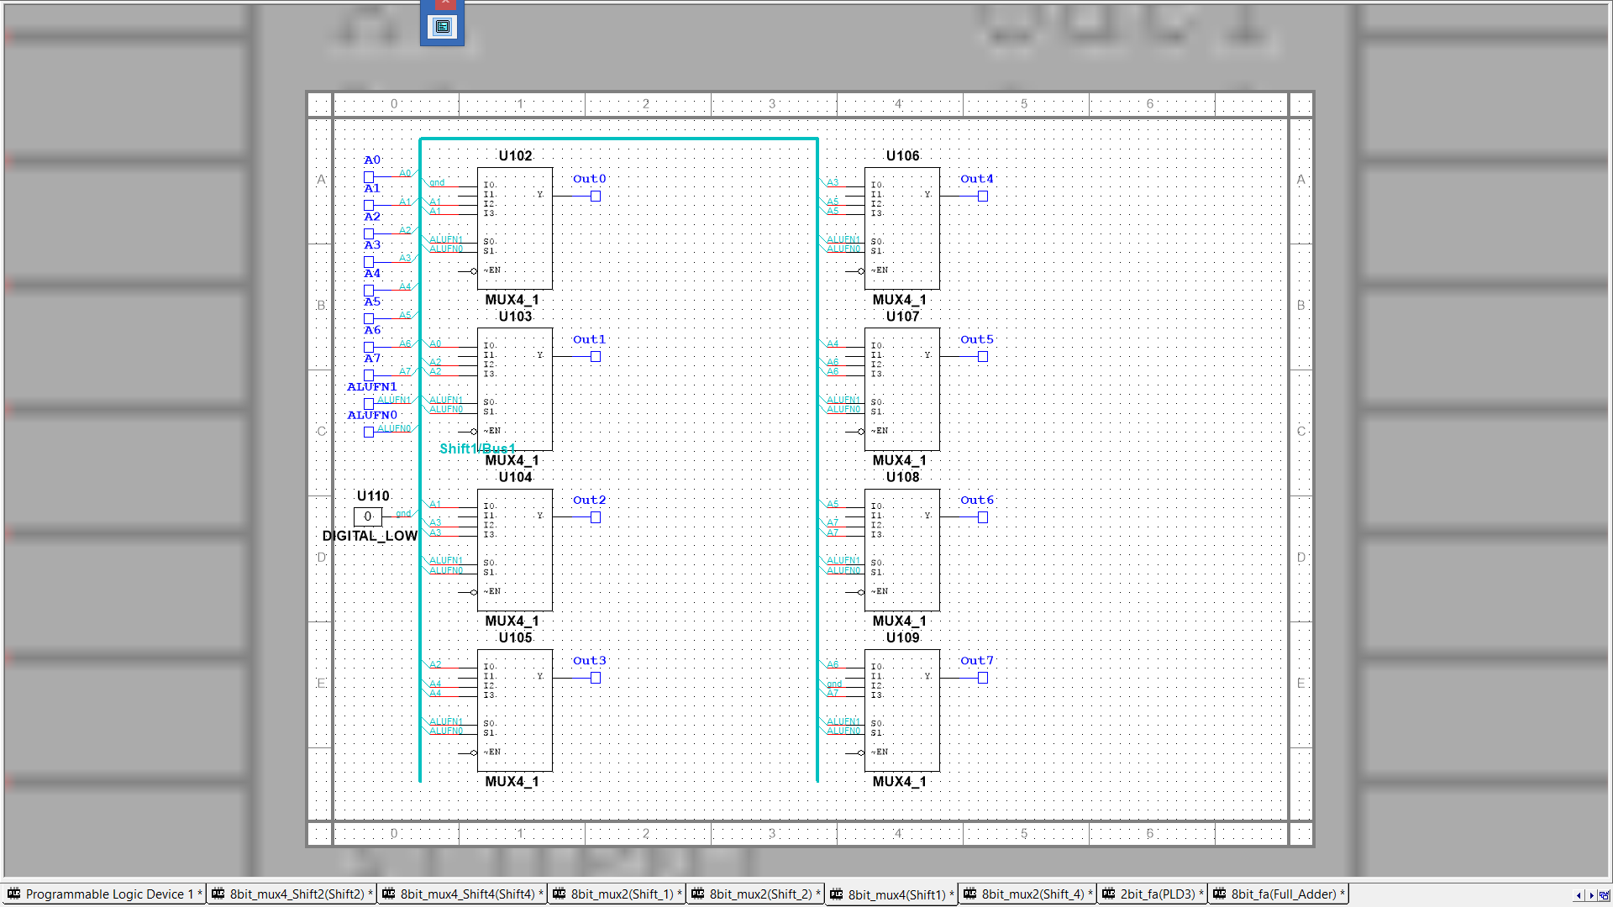

Block 3: 4 Mux 1 bit Shifter(8bit_mux4(Shift1))

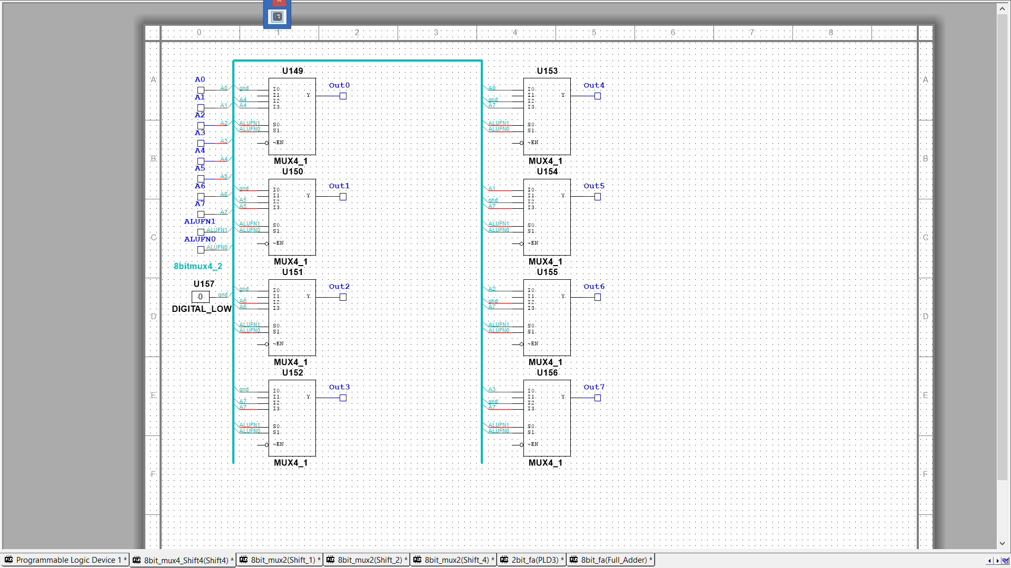

Block : 4 Mux 4 bit Shifter (8bit_mux4_Shift4)

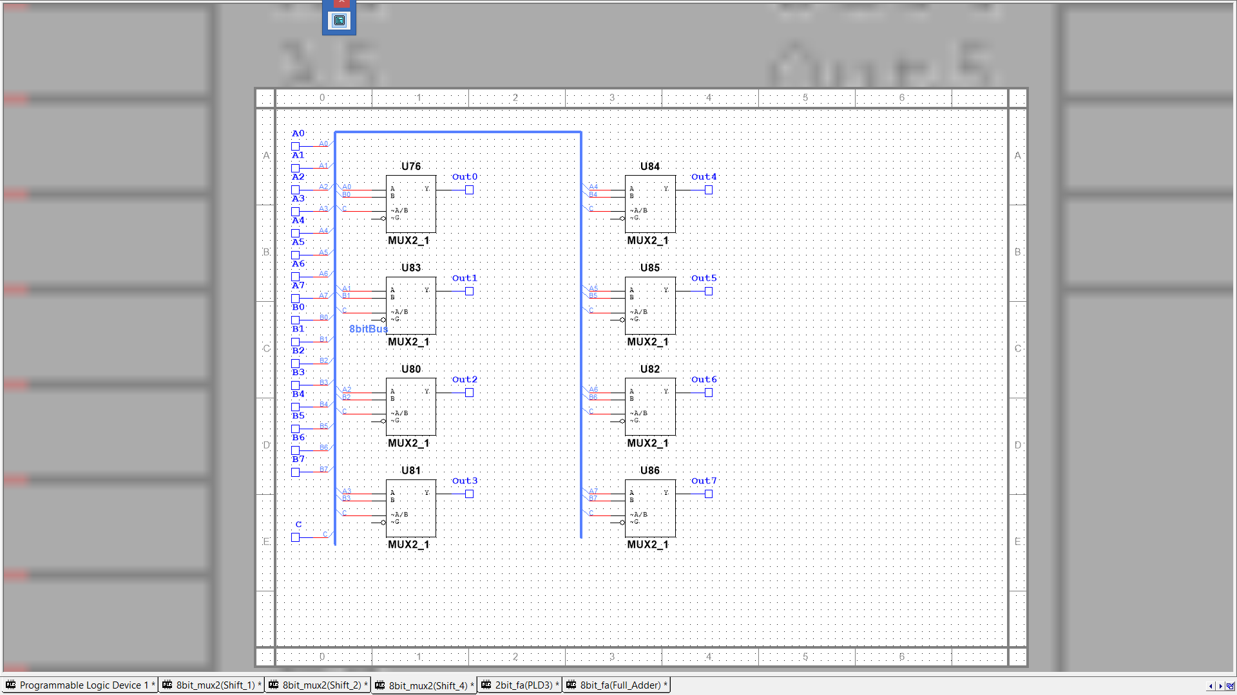

Block : 2 Mux Shifter Selector (8bit_mux2)

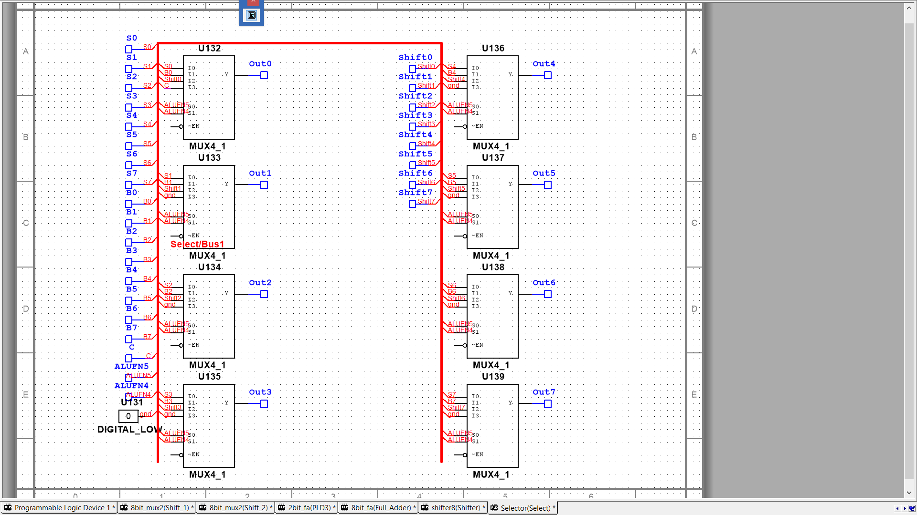

Block : PLD Selector(Select)